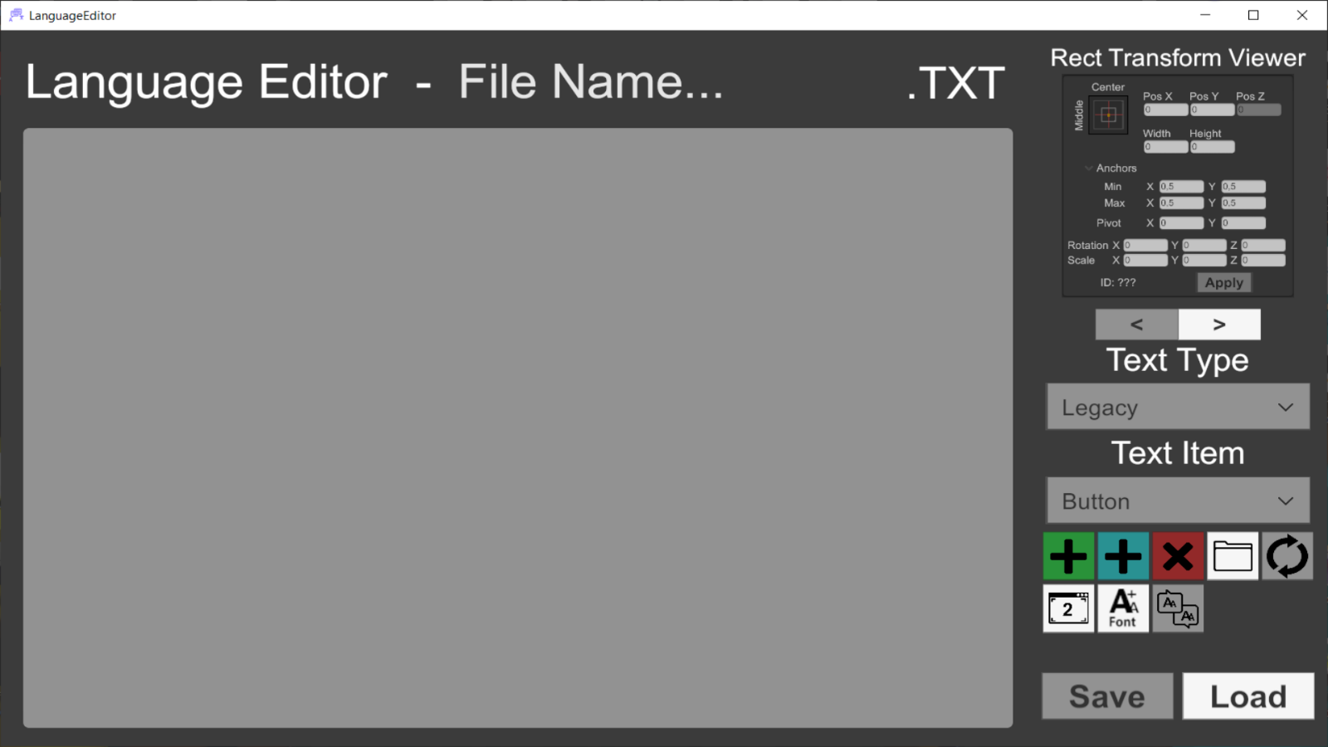

**Language Editor**

Documentation

_____

**Creator:** Lucas Gomes Cecchini

**Online Name:** AGAMENOM

**Overview**

This document pertains to the **Assets Language Editor** an add-on to **Assets Language** for **Unity**.

With it you can more easily edit the text files of your games. It also gives a rough preview of how the modified text would look in-game.

To make file selection easier, the **System.Windows.Forms** DLL available at [DLL‑files.com](https://pt.dll-files.com/system.windows.forms.dll.html) was added.

**Instructions**

You can get more information from the Playlist on YouTube: <https://youtube.com/playlist?list=PL5hnfx09yM4JkAyxrZWaFjhO3NMWxP_1F>